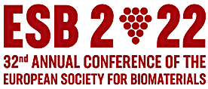

Registration Form
“Meet the Professors”

First Name:
Last Name:
Affiliations:
Degree:
Email:
City:
Country:
Zip code:

Give 5 Keywords of expertise of the Applicant:

Select one Lunch meeting table with Pr: Complete the name of the Professor

The date of the lunch meeting (September 5th, 6th, 7th) will be updated before the conference

Please send this registration form to meettheprofessors@esbbordeaux2022.org

